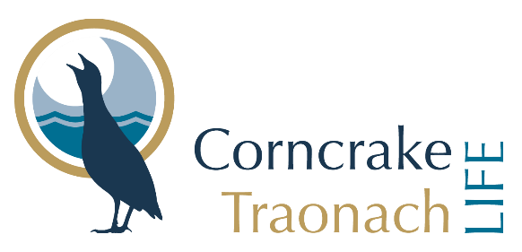

Events & Training Attendance
Thank you for attending this event.

The Corncrake/Traonach LIFE project wish to record your attendance and participation at this event for administrative purposes.

In addition, in order to disseminate information about the Corncrake/Traonach LIFE project and its activities, the Corncrake/Traonach LIFE Project Team may wish to photograph/film/record events which it is organising or involved in. Such events may be related to the project’s RBPS, its meetings, training and information events, and could take place in public locations, on private lands or online. The photographs/recordings may be used in both printed and digital forms in conjunction with project stakeholders, associated beneficiaries and the media. Given that you have indicated your wish to participate at such events related to Corncrake/Traonach LIFE project, it is possible that you will be photographed/recorded during your attendance and/or contribution. Therefore Corncrake/Traonach LIFE asks that you consent to the use of your personal data, both in the form of an attendance record and/or such images or recordings, for administration and in the promotion of the project’s work and activities. If you do so, you will continue to have the right to withdraw your consent at any time, in which case Corncrake/Traonach LIFE will no longer use your personal data in new information material and will endeavour to remove you from already published material, wherever possible. Upon request, you can receive a Privacy Statement with further details on this data processing and your rights.

Consent to Corncrake/Traonach LIFE processing your personal data for (i) event attendance and participation record; (ii) the purpose of disseminating information about the project and its activities

I hereby consent to Corncrake/Traonach LIFE storing and processing data related to my attendance at an event for their administrative purposes and to fulfil Covid-19 requirements. I hereby consent to Corncrake/Traonach LIFE storing, processing and publishing photographs/video/audio recordings taken of me on the occasion in question, in both printed and digital form, for the purpose of the promotion and disseminating of information on the project’s activities. The photos/recordings are intended to be published in information material, on the project website and/or on social media, and shared with associated beneficiaries towards the same purpose.

I am aware that I may request a copy of the Privacy Statement related to this usage of my personal data.

Signature: ____________________ Parent/Guardian_______________________

Print name: Date: / /

