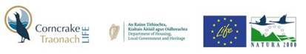

**CorncrakeLIFE Schools Programme 2022**

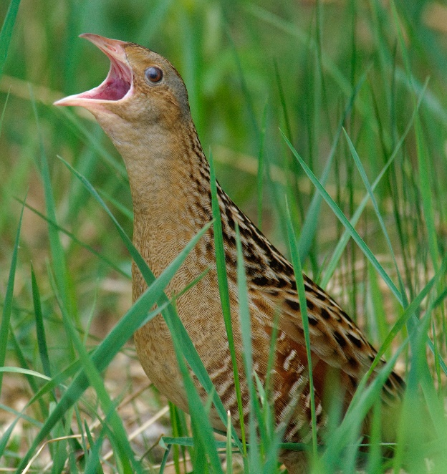

Corncrake/Traonach LIFE Project as part of its community engagement strategy have designed a schools educational programme to complement and support its goals. It aims to educate primary school children from 3rd to 6th Class on the Corncrake, its ecology and its value as an asset to the community. The programme can be delivered in a bilingual format. The model of delivery will include emphasis on existing Science, Technology, Engineering, Arts and Mathematics (STEAM) subjects and incorporating our delivery into this curriculum. It will be a developmental programme which incorporates different styles of learning. Delivery will be a blend of information sharing, indoor and outdoor activities to raise awareness of the Corncrake, the impact of farming practice, and highlighting the power and capability that each individual holds to positively affect their environment and wildlife.

The CorncrakeLIFE Schools programme is committed to connecting young people with local nature and empowering them to protect their natural world now and into the future.

Research has shown that there is significant correlation between children’s connection to nature and nature near their homes. Our field trips to local Corncrake habitats aims to focus the children on the abundance of wildlife and nature in their locality.

Initially three sessions in eight schools across Donegal, Galway and Mayo was planned as part of this pilot. Time required per session is approximately 70 minutes. Selection of target schools is based on geographical relevance to areas where corncrake appear currently.

CorncrakeLIFE Schools Programme will provide children with:

* A deeper understanding of their local wildlife, heritage and landscape.
* The chance to experience and participate in a local conservation project.
* Practice of skills: problem solving, communication, team work, goal setting.